Principles of Frying Fish and Chips

Learner
Workbook

Title | Principles of frying fish and chips
Level | 3
Credit value | 4
Learning Outcomes | Assessment Criteria
The learner will: | The learner can:
1. Understand the principles of raw materials for frying fish and chips | - Describe the types of commercial frying fish, their characteristics and suitability from a business and customer aspect  - Summarise the variations in potato characteristics and the impact of season, storage and variety on the selection of potatoes for chipping  - Explain the advantages and disadvantages of using propriety batter mixes  - Explain how to store fish, potatoes and other raw materials for frying.
2. Understand the principles of fats and oils for frying fish and chips | - Describe the importance of choosing to use fats or oils of the correct type for frying  - Summarise the range of fats and oils available and the impact of UK regional preferences  - Explain the chemical structure of frying fats and oils  - Explain how the chemical structure of frying fats and oils are affected by heat over time  - Summarise why it is necessary to manage fats or oils to avoid deterioration in the quality of the frying medium and fried products  - Explain the meaning of the terms slip point, smoke point and flash point for a fat or oil and their importance for the operating temperature of the fryer.
3. Understand the principles of heat transfer and frying of fish and chips | - Describe how heat is transferred from the frying media to a deep fry product  - Explain the physical changes that take place within products during the frying process  - Describe how the absorption of fats into the surface of products during the frying process is important to the eating quality of the product and its resultant calorific value and perceived impact on diet and health  - Summarise the effects of frying with too low or too high a temperature  - Summarise the effects of frying for too short or too long a time.
4. Understand the principles of error avoidance, and the impact of sustainability and the environment on fish and chip frying | 4.1 Summarise how to avoid common errors in frying fish and chips  4.2 Describe the current state of fish stocks and issues of sustainability and the environment that impact upon the fish and chip sector.
Achieving the Unit

The following information will support you with the knowledge requirements to help you achieve this unit.

Whilst this booklet provides a good source of information, it is not exhaustive. We recommend that you research information yourself via the internet or at your local library. Useful sources of information include the Sea Fish Industry Authority (www.seafish.org) and the Seafood Training Academy (www.seafoodacademy.org).

Seafish and others have developed a range of training resources in fish and chip frying including:

- The training DVD Fish Frying Skills, the movie;
- A fish frying skills work-based qualification and associated trainee support pack available as a written text for trainees, and also via the frying skills gallery on the Seafood Academy website;
- The National Federation of Fish Friers provide one and three day training courses at their fish frying training school in Leeds, and have kindly provided significant content for this workbook.

There is more information on resources at the end of this workbook.

…………Good Luck!

Lee Cooper
Seafish

All the images and photos used in this Learner Workbook have been sourced by Seafish.
UNIT DETAILS

Unit Number: FP.152K

Unit Qualification Number:

Title: Principles of frying fish and chips
Level: 3

Credit Value: 4

UNIT AIMS

This unit supports workforce development for those who are responsible for the frying of fish and chips in fish and chip shops and restaurants.

The unit is designed for use primarily by supervisory level staff with a responsibility for the cooking operations in these establishments. The aim of the unit is to assess knowledge and understanding to recognised National Occupational Standards.

CONTENTS

Section 1: Introduction and Raw materials

Section 2: Fats and oils as frying media

Section 3: The cooking process

Section 4: Common Errors and how to avoid them

Section 5: The state of fish stocks and customer concerns over sustainability

Section 6: Additional resources
SECTION ONE:

INTRODUCTION

Within the context of this Learner Workbook and the associated Improve Proficiency Qualification, frying fish and chips is carried out in a variety of locations including mobile and high street fish and chip shops, speciality fish and chip restaurants and similar establishments.

RAW MATERIALS

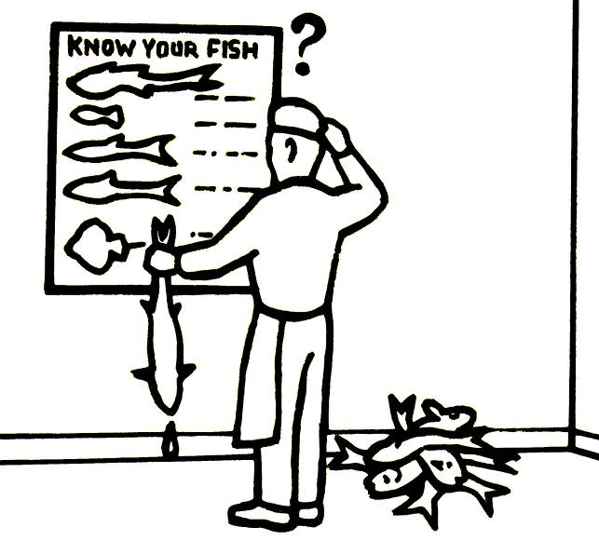
Raw materials include fish and potatoes, or partially prepared chips. Fish may be whole fish requiring filleting and skinning, fish fillets requiring only trimming and portioning, or individually frozen fish fillets that have to be defrosted and portioned prior to battering or breading.

Prepared and coated fish portions ready for frying without any other preparation are not covered by this section.

As the quality of these raw materials are likely to change throughout a season and even from day to day, “success in this business is dependent upon the fish frier not only understanding what changes are taking place, but why they are taking place. A constant striving to produce a consistently high quality product is the mark of the successful fish and chip business.”

FISH SPECIES

There are many varieties available in the UK and suitable for frying, although customer preferences are usually limited to cod and haddock and the occasional flatfish. Other species (including shellfish) that are often seen in UK fish and chip shops are:

- Cod;
- Haddock;
- Plaice;
- Skate;
- Dogfish (Huss);
- Sole;
- Scampi.

Other species that may also be sold in fish and chip shops and restaurants include:

- Whiting;
- Catfish;
- Monkfish;
- Trout;
- Salmon.

To find out what is available in your region you should look around fish and chip shops in your area and perhaps talk to the shop owners to see if they have customers with tastes for fish other than cod and haddock.

It is usual for a region to serve either cod or haddock and to have some other species available to order.

Cod and haddock are both round white fish, as is whiting. It is important that whatever species of fish you serve it is clearly and accurately described.

Whiting should never be sold as small haddock – know as waddock by those traders unscrupulous enough to do so, and catfish (Vietnamese catfish or pangasius) should never be passed off as cod. It is illegal to misrepresent food items in this way.

Can you tell the difference between species? For more information on identifying whole fish and shellfish visit www.seafoodacademy.org.
Identifying the type of fish when it arrives with its skin intact and head on is one thing, but when it is skin off, battered and cooked it is much harder, but not too difficult for an expert so don’t be temped to cheat. If you do want to sell other species of fish then be honest with your customers. After all, there may be a market in your area for whiting and chips.

Apart from the species of fish to be battered and fried, we should also consider the form and the quality.

FORMS OF FISH

Essentially we are referring to the frozen or unfrozen state of the fish. Whether the fish is frozen, never previously frozen or defrosted, it is important you choose which is best for you.

Once you’ve decided on the types of fish you wish to use, you can buy it wet or frozen.

Wet Fish

Wet fish needs immediate handling.

The contents of the box should be separated out, re-iced and then put straight into your fish fridge otherwise the whole point (freshness) will be lost.

Wet fish must be kept moist and should be delivered and stored at a temperature of approximately 1º to 2 ºC. Try not to order more fish than you expect to use within two days.

One disadvantage of wet fish is that its price varies as the supply varies. This makes your costing process more difficult.

The other disadvantage is that quality can vary significantly from day to day unless your supplier is careful and consistent.

Wet fish is more often referred to as fresh fish and chilled fish. Fresh fish is not always accurate as the fish may be of poor quality and far from fresh. Chilled fish is often taken to mean that the fish has never been frozen and this may not always be the case.

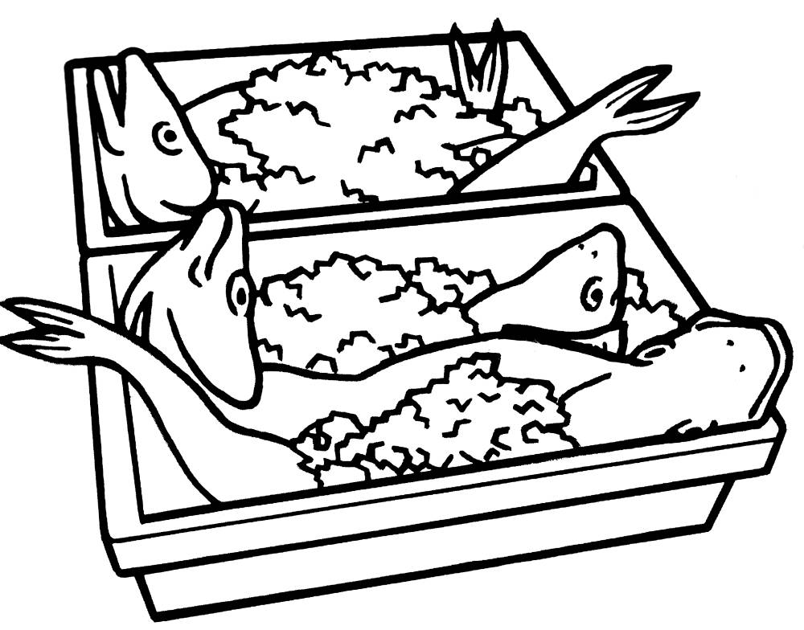
There is a significant amount of fish landed in the UK that has been headed and gutted and then frozen. This fish is defrosted by the processor, filleted and may then be sold as wet fish. The quality is often very good.

Wet, fresh or chilled - however it is described, you should ask your supplier to be precise about how the fish has been handled prior to delivery.

Frozen Fish
The range of frozen fish products available to caterers includes:

- whole fish, either single or in blocks;
- fillets frozen singly or in blocks;’,
- interleaved blocks of fillets known as shatter packs, and;
- pan-ready portions of various shapes cut from laminated blocks of fillets.

Fillets, portions and fingers are also available battered, or breaded. Products made from sea-frozen fish are normally not more than two days in ice before they are frozen and, therefore, are of consistently high quality.
Frozen products prepared at the ports from wet fish landings are made mainly from very fresh raw material, but the age of the wet fish used could be anything from 1 to 17 days in ice.

When frozen fish is delivered to your shop, the temperature of the fish should be no warmer than -15°C. If it is then you may need to reject the delivery and you will certainly wish to take this up with your supplier.

Frozen fish needs different organisation from wet fish, as you need to get it out of the freezer in advance. You therefore need to know your likely customer demand in order to decide what you’ll need tomorrow.

However, as long as you have enough frozen fish in stock you should never run out provided you defrost enough.

As defrosted fish will begin to lose quality just like wet fish once it is thawed out, and because you should never refreeze it, you will not want to defrost too much.
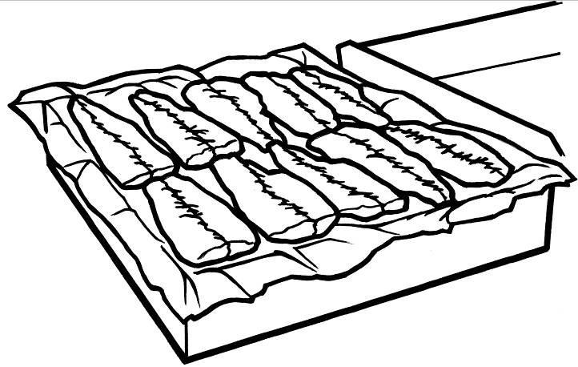
Even if your main raw material is wet rather than frozen fish, I advise you to have a box or two of frozen fillets is reserve for those occasions when your supplier lets you down, or an unexpected coach party uses up your weekend stock on a Friday.

The individually quick frozen fillets (including shatter packs) have the advantage that you only need to defrost the number of fillets you need.

It is best not to fully defrost a frozen fillet. You can tell when it has gone far enough, because it can be comfortably cut with a knife.

What about frozen portions?
Frozen portions come in a block. They are ready boned and skinned so the wastage in preparation is no problem. They give you perfect portion control and so help you do your costings perfectly.

Which is best?
Generally, which form of frozen fish you choose will depend on your preference.

It used to be said that wet fish is fresher than frozen fish, but with correct handling and quick-freezing methods, this is often not true.

• Frozen fish maintains a predictable price.
• It is always available.
• The quality of frozen fish is consistently high.

Frozen portions offer the same consistent price and quality.
• They can offer greater economy.
• There is no labour or time needed for preparation.
• Each portion weighs the same and could work out cheaper because there is no wastage.
• Not popular with the customer in most instances due to their
regular shape.

Frozen fish therefore allows you to budget more closely over a longer period than with wet fish.

The best way for you to decide is to have a good look at the market and think about:

- The availability;
- The all the year round cost;
- Wastage.
- Then decide which type would best suit your organisation.
- How many people work for you?
- Could you be organised enough to cope with frozen fish for tomorrow?
- Could you organise to cope with wet fish that needs to be skinned, boned and portioned?
It is possible that the best thing for you is to use a mixture, for example, wet fish backed up by a few days supply of frozen fish.

FISH QUALITY

There is an old saying of fish sellers

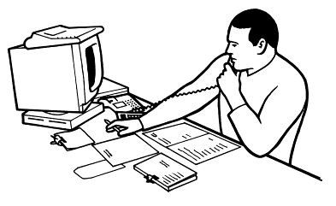
“Today I have high quality and low prices. Which do you want?”

Whether your business is to sell fish and chips made from the highest quality fish available, or to provide a lower cost nutritious meal, quality and price are key.

The relationship between price and quality is not always a clear one. The quality of fish available can vary during the week and throughout the season, as well as from supplier to supplier.

It can be a real juggling act trying to make sure that the quality and price of the fish that you buy meet your needs, which is why many fish and chip shops use dedicated suppliers of wet or frozen fish.

These dedicated suppliers understand the need to maintain consistent quality standards within a delivery and from one delivery until the next, as customers can be ‘put off’ by marked changes in the quality of the fish served.

As a general guide, you should look for these qualities when buying wet fish.

Specification | What to look for
Colour (blemishes) | There should be no signs of bruising, blood clots or discolouration.
Bones, skin and belly lining | Only the pin bones should remain. All  of the other bones should have been removed during filleting.
Worms and parasites | The maximum tolerance for nematode worms is three worms per 3.2Kg (7lb). No other parasites should be present.
Eating quality | The fillets must not contain abnormal intrinsic odours or flavours such as  ‘weedy’ or ‘diesel’ flavours. N.B The fish must score at least 6 on the Torry Taste Panel Scoring System for cooked fish.
Packaging | Wet fish should be packed in non-returnable, lidded, water-resistant packaging of such material that will not impart a taint to the product.

These are simple criteria that also apply to frozen fish once it has been defrosted.

The Torry Taste Panel Scoring Scheme

This is an important method of determining the quality of the fish that you sell. We’ve included the scheme for cod and haddock as an appendix at the end of this workbook and we strongly suggest that you have a go assessing the quality of your own fish. The Seafood Training Academy has developed a seafood quality assessment course specifically for fish friers and Seafish have a training DVD available.

Most fish and chip shops seem to settle on fish with a Torry Score of 7, while some others seek to achieve an 8. No fish and chip shop worth its name would routinely sell cooked fish below a score of 6 and expect to retain many customers.

Frozen at sea fish should score a good Torry 8+ if it is cooked within 12 hours of defrosting in a fridge. We recommend that the fish is cooked in a microwave for a few seconds so that there is nothing to add extra flavours – no salt, no vinegar or batter to improve the flavour.

ACTIVITY

How you approach this activity depends on how you obtain your fish, and how frequently you receive deliveries.

Whether you receive daily (or less frequent) deliveries of fresh fish, defrost from frozen at sea, or some other supply pattern, the aim of this activity is the same.

Over a period of a week you need to collect a series of chilled fillets that range from the freshest you have delivered, to one that is a week older than the freshest, and 2-3 in between if possible.

The collection may be complicated by your supplier. Even if you have daily deliveries it is likely that your supplier has them less frequently, and so the fish delivered to you on day 1 and 2 may actually be from the same batch. Talk to your supplier about this. If you use defrosted frozen fish then you have complete control over when you defrost each sample. It may even be worth buying a small batch of frozen fillets from your local supermarket just to simplify this activity.

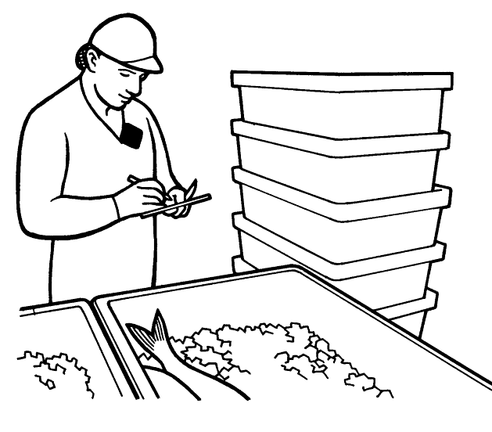
Starting at the beginning of the week, keep back a small fillet from each delivery or defrosted batch until you have 4 or so fillets ranging in age. Keep them separate from your normal fish and keep them individually labelled.

At the end of the week cook up a small piece from each fillet and compare the change in flavours from the most recent to the oldest fillet.

Cooking: microwave on a low setting. Use just a small piece of the fillet – perhaps around 50gms and add a little water to the lidded container to keep the fish moist.

Quality Assessment:

- Use the Torry scale in appendix 1.
- Lift the lid of the cooked fish and gently smell the steam given off – take care not to scorch your nose! Look down the scale for odour, do you smell any of the descriptions? Write down what it smells like to you.
- Flavour – take a bite, have a chew and suck out the juices from the flesh. What flavours do you detect? Write down what it tastes like to you.
- Texture and mouth feel – chew some more of the fish. Does it get firmer and drier as you chew, or sloppy? Does it fit neatly within the descriptions on the Torry scale? Write down your own impressions of the texture.
- Repeat this for each fish sample, ending with the oldest.

Congratulations, you have completed your first ‘objective’ fish quality assessment. We say objective because when describing the odour, flavour and texture of the fish you should have used words such as milky, sweet, fibrous and not words like horrible or nice.

If you want to know more about the practical side of assessing the quality of fish and shellfish then Seafish have developed for fish friers a short practical course in fish quality assessment.

Q. Can you describe the types of commercial frying fish, their characteristics and suitability from a business and customer aspect?

By types we are really talking about the forms (frozen/chilled) as well as whether the fish is whole, requiring filleting, in fillets – requiring portioning, or even as portions.

By now you should be able to decide why the fish types you fry, or plan to fry, are best for your business and for your customers. You should also have a clearer idea of what is acceptable quality when it comes to the wet fish fried in your business.

To help you with this we have prepared a table that you might like to use to record your thoughts.
Suitability of fish

Species | Cod? Others?  Haddock?  Plaice?
Why?
Chilled or Frozen
Why?
Whole fish, fillets or portions
Why?
Size ranges served
Why not larger or smaller?
Ideal quality Torry score
How is this achievable?
Lowest acceptable Torry score
What action to take to avoid this?
POTATOES

Potatoes are a very important part of a fish frier’s life. It is vital that your chips are of a high quality and that you avoid selling a greasy product. There’s nothing worse than soggy chips for spoiling your reputation and therefore your trade.

Which potato to choose
There is no variety of potato which can be said to give a consistently high
chipping quality. There are many varieties that you can use and amongst them are:
- Maris Piper;
- Desiree;
- Pentland Crown;
- Cara;
- Romaro;
- Edward.

Markies are a new variety that have become more popular over the past few years.

All of these can be used for making chips but whether or not they will be
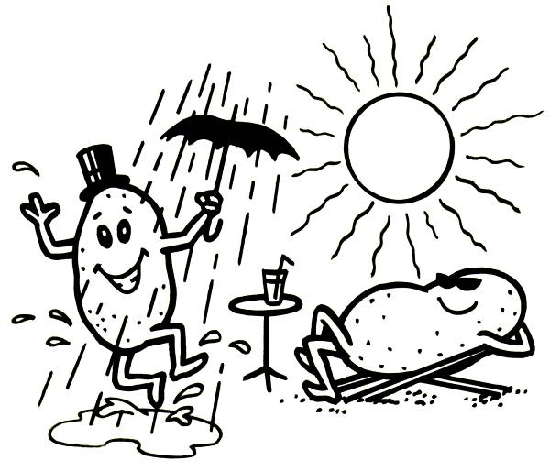
consistently good depends on several things.

What affects the Chipping Quality?

- Soil and Weather
The condition of a potato when it reaches your shop will be brought about by the soil and weather conditions under which it was grown. The same potato grown in different soil, or in a different part of the country, will be a different quality potato.

- Condition
The physical condition of the potato is important because it can cost you money. Badly damaged potatoes will lose more weight than ‘perfect’ potatoes. This applies also to:

• Oddly shaped ones;
• Potatoes which have started to sprout because of poor storage;
• Diseased potatoes affected by blight.

Such potatoes will be mottled brown on the outside and marbled grey on the inside. They lose more weight because they get left in the peeler (rumbler) longer and more of the flesh disappears with the imperfections.

- Age
The age of the potato is important for the length of time it will take to peel it. When potatoes are newly harvested, their skins are thin and easily removed. As they age, the peeling time increases. The time
increases also because of the lower water content of older potatoes that are more ‘rubbery’ than newly harvested ones. It is important to explain that age applies to how long the potato has been growing, as well as how long it has been in storage since it was harvested.

Sampling
This is by far the best way to choose your potatoes. Ask your merchant for a
sample. The British Potato Merchants/Growers Association (BPMA) have
a British Quality Chip Charter supported by the British Potato Council (BPC) and the National Federation Of Fish Friers (NFFF). This lays down a
minimum standard for chipping potatoes.

A copy of this standard can be obtained by contacting the BPMA, the BPC or the NFFF.

Now you’ve got your sample, what should you look for?
The most important thing is the quality of the chip at the end of the frying
process. That’s going to have an important effect on your business.
The second most important thing is the yield. How much wastage is there?

WASTAGE
Knowing about wastage in potatoes is very important for your business. You
will not be able to predict the yield of a bag of potatoes precisely but you should always know roughly what you’ll get from it. Wastage of potatoes will be caused by:

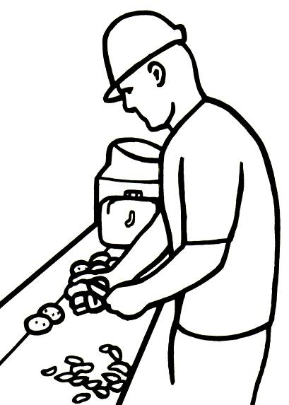
- Incorrect peeling times (these would usually be no more than 1½ minutes depending upon the quality of potatoes used);
- Not finishing peeling off by hand;
- Incorrect grade of carborundum;
- Overloading the ‘rumbler’;
- Buying poor quality potatoes.

You must work out the correct grade of carborundum when buying your rumbler otherwise you’ll lose flesh during peeling. This also applies if you overload the machine.

If you are going to leave potato peeling to someone else, do make sure that they know all about correct peeling. It is important that you convert as much potato as possible into chips. If you don’t, your profits will fall and the Inland Revenue will take your potato purchases and expect a higher income than you get. This could cause problems in assessing your tax.

How to store potatoes:
- Potatoes must be stored on pallets in a dry place at between 7°C to 10°C. Damp potatoes will sprout or go mouldy;
- Potatoes must be stored away from the walls, no higher than six bags high in a cool and dark environment;
- As with wet fish, potatoes don’t have a use by date on their packaging. So it is good practice to write on the packaging the date that they were delivered.

These potatoes must then be placed beneath any existing bags. This will
ensure that your oldest potatoes are used first and will also reduce the
chances of your stock becoming substandard. Remember that potatoes
that are substandard will impact on your profits, as you will have to dispose
of these potatoes.

Correct storage of potatoes is easier if you don’t buy too many at one go.
Buying in bulk is not necessarily economical if you’re going to lose some of the stock. Also, if there’s any disease, you’ll find it will spread through the whole supply.

Sugar content of chipping grade potatoes

To produce even coloured chips it is necessary to ensure that potatoes contain no more than 0.25% sugar.

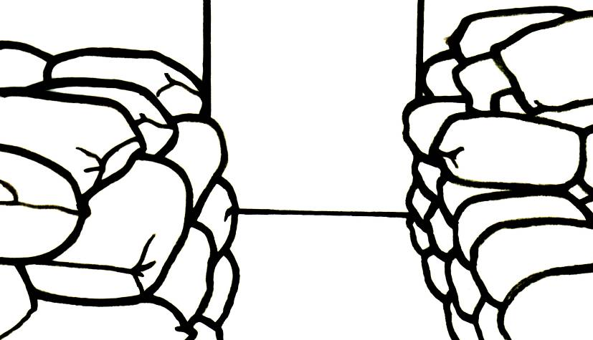
When a potato becomes chilled in cold weather through either being stored at very low temperature, on a cold floor or in a draught, the potato undergoes a change that converts some of its starch to sugar to provide energy to combat the cold.

Potatoes affected this way, when chipped and fried will turn dark brown in
colour. This is called caramelisation. The resulting chips will also taste sweet
and will soon become soggy. They may also damage your frying medium and require the oil/fat to be changed.

Potatoes delivered in very cold weather should be tested for sugar content
before being accepted. Use a sugar testing kit available from some sundries merchants, or you can use Diastix (for Glucose), which are diabetic reagent sticks available from the chemists.

Method
Cut a small potato in half; hold the stick between the closed halves of the potato for 30 seconds.

Compare the resulting colour change with the chart on the side
of the tube. This will indicate the severity of any sugar level increase.

Potatoes with a high level of sugar can be treated with Drywite Starch Doctor or, after washing out excess starch from the chips, place them in a tub and cover them with very hot water and allow to cool. This will leach out the sugar.

Par fries/chilled chips

Some businesses may decide to use par-fried chips rather than prepare chips from the raw potato. Par fries are chips that have been partially fried to prevent discolouration, drained, then vacuum-packed.

When this is the preferred option it is important that correct storage is observed.

When these chips are delivered they must be placed in a fridge or chiller and kept at a temperature of about 2ºC to 4°C.

It is advised that they be used within 3 to 5 days.

For further details on storage and frying, you should follow the manufacturer's guidelines on the packaging.

BATTER
Good batter is essential to your trade as a fish frier. Poor quality batter could
ruin you, so it’s important that you know what you’re doing. You can either
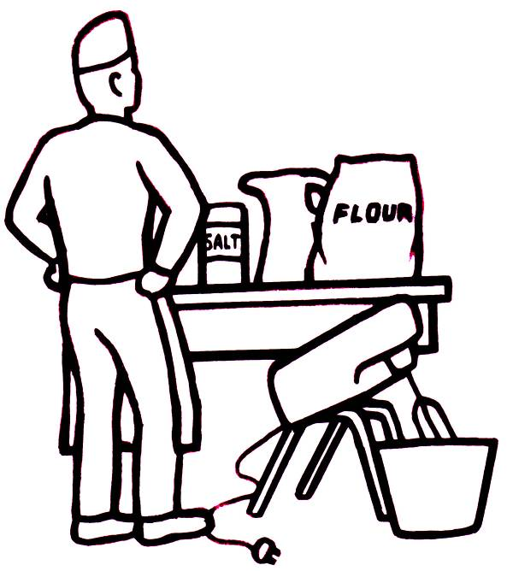
make your own batter or use one of the proprietary brands.

Proprietary brands

The biggest advantage of using a pre-mixed batter is that you know, (if you follow the instructions) it will be consistent.

Good batter needs the right grades of flour and other ingredients in a correct balance. It should coat the food evenly and fry crisply. Good batter should ‘look good’ in terms of colour.

You’ll find that pre-mixed batter helps you achieve all this. Another advantage in using a proprietary brand is that it is quick to use.

You can store it in advance too; so you can meet sudden extra demands.
Pre-mixed batters are specially blended not to absorb too much fat - a great advantage.

To the inexperienced fish frier, pre-mixed batter is of considerable help.
Look around at the type of pre-mixed batter on the market.

There is a special batter formula available for cooking frozen fish portions as these give problems when they are fried from frozen.

How to use a Proprietary Brand

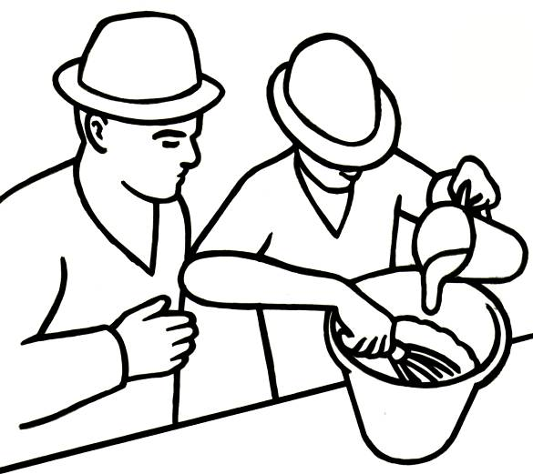
Obviously a pre-mixed batter will only work well if you follow the instructions properly. To mix it properly you should:

- Always use cold water (max temp +15°C);

- Add the mixture to the water;

- Stir briskly whilst adding it;

- Make sure it’s smooth;

- Allow to stand for at least 30 minutes if possible;

- Keep it cool once it’s mixed.
What good batter should look like

What is considered to be good batter will change from place to place. Make sure you know what people in your part of the country prefer. But, as a guide, good batter should be thin. Thin batter is not only economical but gives good results. Ideally batter ought to be the consistency of thin cream and should slide off a spoon easily.

The Effect of Poor Batter

You want your end product to appeal to your customers. The end product should be properly cooked and nicely presented. Poor quality batter could let you down seriously. If you make the batter too thick, it will be soggy on the inside. You may also prevent the fish from cooking properly. The product will not look crispy and inviting.

Batter that is too thin (or too warm) will nor properly seal the fish and protect it from the hot oil. Your fish may turn out greasy or dry or both!

Storing batter

- The plain flour or pre-mixed bags should be stored in a dry place. The bags should never be allowed to become damp.
- Store loose flour in bins with tight-fitting lids.
- Don’t leave partly used bags open to the air.
- Once the batter has been mixed, you must keep it cool by storing it in the fridge, if possible. (Mixed batter must never be allowed to become tepid.)
- Don’t make more than you need for one frying session. You should not keep batter overnight so mixing too much is wasteful. Batter kept overnight that is used for frying on the following day leads to a darker colouring of batter and quickly looses its crispness.

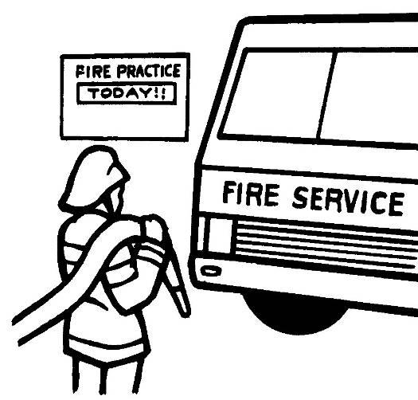
Batter scraps

It is worth noting that any unused batter scraps must be stored in a metal
container with a lid, outside the main building, prior to disposal. This is because batter scraps are capable of spontaneous combustion. Next to fires in the vent flues from frying ranges, they used to be a significant cause of fires.
SECTION TWO

FATS AND OILS

What to fry with?

Choosing a frying medium is very important, in some ways more important than the type of batter mix or even the quality of fish used.

When you are deciding what you are going to use to fry with, you’ll have to have a good look at the preferences in your area of the country.

Parts of the country such as Merseyside and Lancashire prefer solid vegetable fat, while the people of Yorkshire seem to like animal fats such as beef dripping.

In the South of England more use is made of liquid vegetable oils. Many ethnic groups prefer palm oil and palm oil blends.

These preferences are personal but you should find out what is generally used around you. If you decide to use a different frying medium from the one commonly used in your area then you should have clear reasons behind your decision. Perhaps you want to position your business as a healthier alternative and want to use one variety of oil to achieve this.

OIL vs FAT

Nutritionally they are all fats with a similar level of calories per 100grams. Fats are usually used to describe the solid fats, whereas oils are used to describe those fats that are liquid at normal room temperatures.

Oils and fats of vegetable origin
- Groundnut oil
- Vegetable oils, for example, rape seed and soya
- Palm or hydrogenated mix, also known as solid vegetable oil.

Fats
- Dripping – derived from beef
- Lard – derived from pork.

Fats that are solid at room temperature usually have a high degree of ‘saturation’ whereas largely unsaturated fats have a lower melting point and are liquid at room temperature.

Often during this workbook we will use fats when we mean fats and oils.

Criteria to consider when choosing a frying medium

Here are some of our suggestions, can you add anything?

- Locally used – if you want your business to appeal to the local market then you will need to take account of what is used locally. But, be prepared to try alternatives if you think they will appeal to customers more;

- Cost – some fats/oils can be very expensive. Cost is definitely an issue and there should be a return on your investment:

  - “Speciality” oils such as walnut oil are expensive but will impart a nutty flavor like groundnut, but could give you an opportunity to market it as being more healthy;

  - Palm oil is highly acceptable with many ethnic groups, is relatively cheap and long lasting, but has had “bad press coverage” as it is highly saturated. This may be a disadvantage.

- Health perceptions – oils good, fats bad is a very simplistic but pervasive perception amongst those in the population that may choose not to eat fish and chips because of the negative health implications:

  - There are frying practices that can significantly reduce the fat/oil uptake and so produce a lower calorie product;

  - Some otherwise ‘healthy’ oils are readily absorbed by batter and chips and so can contribute to a less healthy, higher calorie product.

- Duration in the frier – how long does your fat/oil spend in your frier? Do you have a high or low turnover, do you need a long life blend of palm oil? Ideally you will not need to replace the fat/oil other than to replenish that taken out on the product. A poor quality of fat/oil would show these characteristics:

  - Discolours too quickly;
  - Sticks to the pans;
  - Foams or froths;
  - Becomes greasy.

- Odour and Flavour – although there will be some odour and flavour imparted by your choice of medium, it shouldn’t be too strong and should be pleasant or neutral;

- Other reasons –add any you feel are important here:

What will you choose?

What frying medium do you use?

___________________________

Why? When answering this question it would help to refer to the criteria above and to list your reasons here.

THE CHEMICAL STRUCTURE OF FATS

Fats are made up of mixtures of ‘triglycerides’

Each triglyceride is shaped like a capital E. The arms of the E are made up of fatty acids and the backbone of the E is Glycerol.
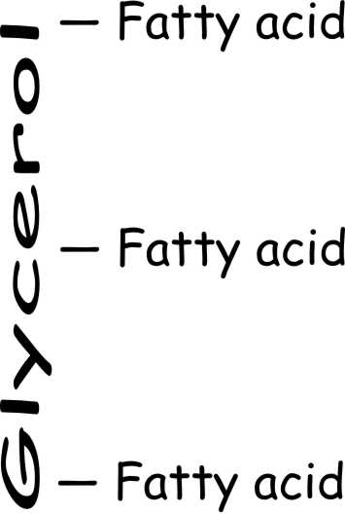
Why is this important?

Different plants and animals produce ‘fatty acids that are longer or shorter. Different lengths of arms results in fats with different characteristics and is one of the things that causes coconut oils to be different from fish oils, or walnut oil or beef dripping.

The length of the arms is not the only important characteristic. We have all heard of saturated and unsaturated fats, and even of polyunsaturated fats, but what does it all mean?

In chemical terms a fatty acid ( the arms of the E) is unsaturated if there is a ‘carbon double bond’ somewhere along its length. If there are more than 1 double bond along the arm of the E then the fatty acid is polyunsaturated.

Carbon bonds are almost always single in everything we eat, from sugars to proteins. Polyunsaturated fats are the main foods we eat that may contain these double bonds. Double bonds may confer important health benefits, but it’s not all good news.

One of the important results (from a frier’s perspective) of this double bond is that the double bond can be attacked chemically – it is a point of weakness. And, the more points of weakness, the more susceptible the fatty acid is to attack from elements such as oxygen.

During the frying process any points of weakness in the carbon to carbon links that make up the fat can be attacked by any oxygen in the frying medium leading to a gradual breakdown of the fat or oil.

Saturated fats have no points of weakness and are considered stable.
Polyunsaturated fats have several points of weakness and can be unstable.
Monounsaturated fats have only one point of weakness and are considered relatively stable.
This chemical breakdown of unsaturated fats during frying is gradual and leads to changes in the characteristics of the frying medium.

This breakdown due to oxygen is called the Oxidative Breakdown reaction.

There are other ways in which the frying medium can be attacked during frying, leading to a deterioration in the quality of the fat or oil.

Attacked by water!

The chemical reaction to make triglycerides (fats) occurs in living organisms and is essentially this:

The significance of the two arrows is to show that the reaction can go in either direction. So fats (triglycerides) plus water plus heat can produce glycerol and fatty acids. This is one of the key breakdown reactions in your frying medium and one of two reasons why you should avoid adding any avoidable water when frying.

This breakdown due to water is called the Hydrolytic Breakdown reaction and as fish and chips are wet before frying it’s impossible to avoid, so you must try and minimise its impact.

Other potential problems with hot fats/oils

During the frying process oils and fats have to combat an array of attack from various sources:

- High Temperatures (Heat required for frying the food);
- Dirt (Particulate matter, namely frying debris);
- Light (Fryer open to contact with light);
- Soaps (Left over from cleaning);
- Trace metals (Equipment/utensils contain oxidative catalysts such as copper, iron or brass).

Attack from these sources will lead to the following Physical/ Chemical breakdown.

Visual effects:

- oil or fat darkens in colour
increased frothing
increased smoking

Chemical effects:

- increased fatty acid levels*
These changes will with time lead to poor odours and tastes, not only in the oil, but more importantly in the finished fried product.

The free fatty acid level, colour level, smoke point and flash point can all be measured analytically, however, in the small frying trade it is the visual signs that are used to monitor the quality of the oil.

There comes a point during the frying process when all these parameters start to accelerate, and it is at this point that the oil starts to break down very rapidly

* Increased fatty acid levels can contribute to:

- greater absorption of fat into batter and chips;
- greater risk of the frying medium frothing;
- more smoking and smoke point temperature is lowered;
- more risk of fire as flash point temperature is lowered;
- reduced quality of finished product.

There are two reasonable actions you can take in response to oil breakdown.

You can replace the frying medium with fresh fat/oil after draining the pans and cleaning them out. This is time consuming, expensive and may be messy, but should your oil get to that point, it is essential you get rid of it unless you want to lose customers.

A more pro-active action is to manage your oil so that you never have to change it, simply replenish it. As every fish and chip portion removes a small amount of your frying medium you will eventually need to replenish this loss. If you take care to look after your oil then it will never need replacing, just regular topping up as each portion of fish and chips takes a small amount with them.

Good Oil Management or minimising the effect of oil breakdown.
Good oil management is about a combination of factors that should be managed.

a. Frying Temperature
Accurate temperature control is essential, the frying of chips should be done between 170 and 180ºC. and the frying of fish should be done between 175 and 185ºC.

Frying ranges are best maintained by the use of a thermostat and it is always good practice to check the accuracy of the thermostat from time to time by the use of a dip thermometer.

Frying at too high a temperature will result in food that is darkly coloured and the breakdown process of the oil will proceed much faster for every 10 ºC above the recommended temperature.

Frying at too low a temperature will result in food being too greasy through excessive absorption of the oil.
b. Correct preparation of raw materials in particular moisture levels
The main cause of oil breakdown comes from excessive moisture on the chips, particularly if the chips are stored in water prior to cooking.

Chips prepared well in advance of cooking will have a tendency to discolour if left for any period of time untreated. Products such as Drywhite allow chips to be treated and stored dry without discolouration.

The key is to ensure that:
- the potatoes are well washed after chipping ( to remove all the free starch that has been released);
- all chips are evenly treated, and;
- all treated potatoes are well drained prior to cooking.

These steps will prevent excess starch and/or moisture making contact with the oil, which will help reduce the speed of oil breakdown.
c. Particulate production and its efficient removal
The main causes of particulate production are batter scraps from the frying of battered fish and other food particles, mainly starches from potatoes which are insoluble in the oil.

The reason particulates are a problem is because they create a large surface area for the oil to react upon, plus the particulates themselves can accumulate, become charred and cause additional breakdown products as well as aid oil polymerisation.

It is always good practice to continue to sieve out the batter scraps after each and every frying, however the very minute black specs which can pass through a fairly fine sieve need a much more efficient system for removal and this involves a more sophisticated filtration system.

All the pans used for frying should be filtered on a daily basis. In most cases the cleaning system involves removing the hot oil from the pan, cleaning the pan by the removal of any built up brown resinous material and then filtering the oil through a very fine mesh back into the clean pan.

Once a week a more thorough clean should be carried out, when the pan is empty it should be given a scrubbing with hot water and detergent. Care must be taken at this point to ensure that all detergent used is thoroughly rinsed away and the frier is completely dry before putting back the oil.

A daily filtration regime which will remove any free particles and a scheduled deep clean which will remove products of polymerization will save you ££s in the cost of your oil.
d. Minimising contact with air and light
When the oil comes into contact with light and air it gives rise to an oxidation reaction (as it reacts with the oxygen in the air) which forms decomposition products.

These products are formed due to the breakdown at the weakest point and they give rise to “off odours” and poor flavours, they also contribute to lowering the smoke and flash point of the oil.

To minimise the effect of light and air the frying range covers should be closed when the fryer is not being used.

e. Minimising contact with soaps
It is recommended that the frier is deep cleaned on a regular basis using a soap or detergent. Care must be taken to ensure that all traces of soap/detergent are thoroughly rinsed away as both soap and alkaline detergents generally promote the breakdown of oil.

To minimise the effect of soaps always thoroughly rinse and dry the pan before adding fresh oil.
f. Minimising the effect of trace metals (copper, Iron, Brass)
Trace metals such as copper and iron have a catalytic effect on the oil breakdown i.e they increase the speed at which the breakdown occurs.

For this reason you should ensure that all utensils, fixtures and fittings are made from stainless steel. In addition it is recommended that salt is not added to the food prior to frying as the sodium ions from the salt (Sodium Chloride ) also catalyse the oxidation reactions.

The key here is to only use stainless steel utensils, fixtures and fittings.

Critical temperatures for Fats and Oils

There are three temperatures that are often quoted for fats and oils. For effective oil management, and to ensure health and safety, you must understand what these are and why they are important.

SLIP POINT TEMPERATURE

The slip point of a fat or oil is their equivalent to the melting point of other substances. It is the point at which the solid material ‘slips up’ a standard tube.

This is the definition from Wikipedia.

The Slip melting point or "slip point" is one conventional definition of the melting point of a waxy solid. It is determined by casting a 10 mm column of the solid in a glass tube with an internal diameter of about 1 mm and a length of about 80 mm, and then immersing it in a temperature-controlled water bath. The slip point is the temperature at which the column of the solid begins to rise in the tube due to buoyancy, and because the outside surface of the solid is molten.
This is a popular method for fats and oils, because they tend to be mixtures of compounds with a range of molecular masses, without well-defined melting points
A more practical definition for the working fish frier is the temperature at which the block of fat starts to soften and melt. It is of limited practical interest to the frier.

The lower the slip point temperature the lower the melting point. Oils will have a slip point temperature well below room temperature, and possibly even below 0ºC

SMOKE POINT TEMPERATURE

Simple explanation – the temperature at which the hot oil begins to give off a bluish acrid smoke.

Technical explanation – above a certain temperature the triglyceride structure of the hot oil begins to break down into glycerol and free fatty acids. The glycerol then breaks down into aldehydes which produce the typical bluish smoke of hot oil close to its flashpoint.

Oil that has reached its smoke point is ‘burnt’ and will need replacing.

FLASH POINT TEMPERATURE (sometimes confused with the fire point)

This is the lowest temperature that the hot oil vapour will ignite. It will not continue to burn, but will ignite and re-ignite.

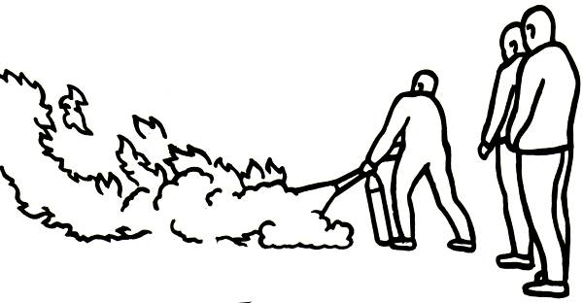
The fire point temperature is slightly higher and is the point at which the hot oil will burn continuously if ignited.

It is IMPORTANT to note that as oil deteriorates the flash, fire and smoke point temperatures are lowered. So if your oil is old and none too clean it may well burn at a slightly lower temperature than you expect.

Ideally your frying medium will have a:

• Ηigh smoke point;
• Ηigh flashpoint;
• Melt at a low temperature.

Typical temperatures
Frying Medium | Smoke point (approx) | Flash point (approx)
Unrefined dripping | 180°C | 302°C
Refined dripping | 204°C | 302°C
Vegetable oil/solid | 204°C | 350°C
What do you use? Insert details

Fats and Oils - Summary
In this document we have covered the main factors involved in the frying process.

We have looked at some basic oil and fat chemistry and the roles heat and oxygen play in oil breakdown.
We also looked at other factors that contribute to oil breakdown and how these can be minimised and controlled.

Finally we looked at some other considerations which need to be taken into account when choosing the correct frying medium, customer preference and geographical region been the most important.
In the final summary it must be said that the life of a frying oil is under the control of the frier and the process he/ she subjects it to with regard to heat, moisture, air, frying debris, light, trace metals and soaps.

The ten commandments of good oil management can be found on the page below.
- Ensure frying temperatures are under effective control
- Sieve out batter scraps continuously during frying
- Filter daily using an efficient system
- Melt down solid fats at lower temperatures (120 ºC)
- Ensure raw materials are well drained and free of excess moisture
- Check the fume extraction system for oil build up on a regular basis
- Minimise light and air ingress
- Empty and deep clean the frier on a regular basis
- Top up with fresh oil on a regular basis
- Do not use copper, iron or brass utensils in the oil.

SECTION THREE

THE FRYING PROCESS

Heat transfer during frying

The process by which heat is used to cook deep fried products has been the subject of many scientific studies. Here we have extracted the main points from one such study.

(a) Fish and chips are usually cooked at starting temperatures between 170 ^{O}C to 180 ^{O}C. The oil temperature rapidly drops on introduction of a batch of chips by as much as 60^{O}C, before finally rising back up to 150 ^{O}C or so. The temperature drop when fish are introduced to the oil is significantly less and fish cook in oil at a higher average temperature.

(b) Heat is transferred from the hot oil to the fish or chips, rapidly raising the temperature of the outside of the product. As the food surface rises to a little above 100 ^{O}C, the moisture in the product starts to boil off.

As the heat ‘soaks’ deeper into the cooking product the temperature of the product rises and more moisture is boiled off. After most of the moisture has evaporated the temperature of the cooking product can rise well above 100 ^{O}C and more chemical changes take place, particularly to the fish encased in batter.

The outside of the chips and the batter coating undergo browning. As chips cook at a lower average temperature (see (a) above) they brown less than the batter coating of the fish.

(c ) Fish - Heat transfer within the batter coated fish is partially by conduction through the batter and partially by the build up of steam within the product. Fish is essentially steamed within a well sealed batter shell and the proteins that make up the fish flesh coagulate or ‘set’ as they are steam heated, changing from translucent to white and opaque.

If the batter shell is broken or the cooking period over extended then the higher temperatures experienced by the fish will cause it to toughen, brown and dry out too much.

Overly thick batter will insulate the fish too well, temperatures will not reach 100 ^{O}C inside the batter shell and too little steam will be generated to properly cook the fish.

(d) Chips - Ignoring the initial surge as water droplets from chips hit the hot oil, there are four recognised phases during the frying of chips. These phases also exist for battered fish, but are less obvious:

- The raw product heats up from its initial chilled temperature. The surface temperature increases far faster that the internal temperature. The temperature of the hot oil plummets from a starting point of around 180 ^{O}C to a little as 120 ^{O}C;
- Water moisture boils off as more of the internal mass of the product reaches 100 ^{O}C. Oil temperature rises but remains close to 120 ^{O}C in the vicinity of the mass of chips;
- As more of the product is effectively dried (moisture content below 10%) the rate at which steam is produced is reduced and the oil temperature rapidly rises again;
- Few bubbles of steam are generated as oil temperatures rise to 150^{O}C and above and the chips start to brown.

(e) Cooking fish and chips at a lower temperature allows more oil to be absorbed into the product, perhaps due to longer time taken to seal the surface of the chip or batter.

Thicker products absorb proportionally less oil as the oil is absorbed into the surface coating.

Holding the cooked product at a higher temperature allows more oil to drain off and reduces the overall oil content of the finished product.

The above is a technical explanation of two aspects of the frying process, namely the transfer of heat into the product and the transfer of water in the form of steam out of the product.

The results of these more recent scientific analysis seems to back up the tried and trusted methods, developed by fish friers over a century and a half, and used to produce first class chips.

In practical terms then, how should we manage the frying process?

Different methods of frying chips

Before we take a look at recommended frying temperatures, let’s look at the different methods of frying chips.

The information below summarises these methods and is taken from the National Federation of Fish Friers’ training manual, which all attendees of their courses receive.

- Frying method: Straight Through

Frying Temperature: 185°C (365°F) Time: 4 to 5 minutes

Description: A full cooking consists of 4.54kg to 5.45kg (10lb to 12lb) of raw
chips. As the cooking session progresses, smaller loads must be used as the oil level drops to prevent overload, excessive water addition and the subsequent breakdown of the frying medium. The chips must be well drained before cooking.

Allow the chips to bunch and rise in the pan, then separate them from
underneath. Do not stir. Never leave a pan unattended whilst frying.
Raw chips on introduction will reduce the temperature of the fat by
approximately 60°C. This is why a high starting temperature is needed.
When the temperature has risen back to approximately 150°C the chips
will be cooked and ready for lifting. The oil must be allowed to recover to 185°C before the next batch of chips is introduced.

- Frying method: Blanching
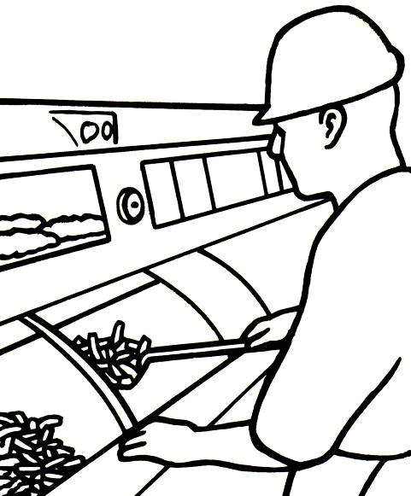
Frying Temperature: 160°C to 170°C Time: 2 minutes

Description: Blanched chips are partially cooked, removed from the fat,
allowed to drain then re-introduced to the pan when the temperature has
recovered to 160°C to 170°C. They fry up quickly and are
useful during quiet periods. They can be used as “stock” during busy periods.

- Frying Method: Finishing

Frying Temperature: 185°C (365°F) Time: 2 to 3 minutes

Description: Fry the chips initially at a slightly lower temperature.
Finish at a temperature of 185°C until cooked.

Storage
Cooked chips should be stored in the chip box, which is normally equipped with infrared heaters. Sometimes they have thermostat controls.

Chips must be rotated in the box. Bring standing chips forward and place fresh chips behind.

Don’t pile chips high at the back of the box or against the element.

Keep the perforated plate on which the chips stand clean on both upper and
undersides.

Recommended frying temperatures

The temperatures and times used for frying will depend on:

- The type of equipment being used;
- The condition of the oil and fat;
- The size of the food being fried;
- Local preferences.

  - Standard Frying Range
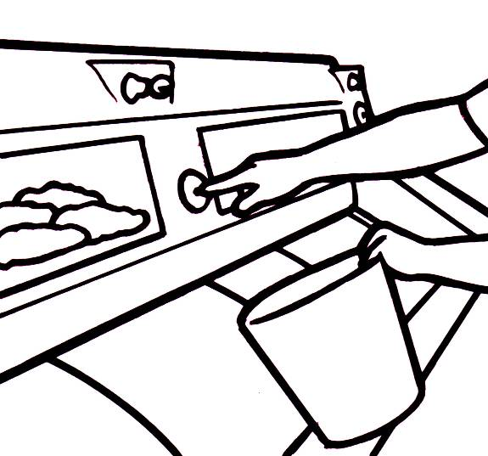
The following temperatures and times are a guide and you should experiment to find the best results. For instance, different types of potato require different frying temperatures and times. The temperatures shown are based on frying chip quantities of 4.54kg to 5.45kg (10lb to 12lb). Slightly lower frying temperatures are recommended when frying smaller quantities because the temperature loss on immersion will be less.

Items | Suggested Temp. | Approx. Duration (mins)
Potato Chips ‘straight through’  Potato chips ‘blanching’  Potato chips ‘finishing’  Fish (battered pieces)  Scampi (battered) | 185 ºC  160 to 170 ºC  185 ºC  180 ºC  177 ºC | 4 – 5  2  2 – 3  3 – 5  3 - 5

  - High Efficiency Range

These ranges are manufactured to provide a more efficient use of gas than the standard range. Manufacturers claim this system can be as high as 94%
efficient. This means that the drop in temperature when frying chips can be as little as 8ºC making recovery times far shorter.

Frying temperatures vary with the type of range and the amount of food being fried. When basket frying it is possible to add 2.27kg (5lb) of chips every two minutes to the pan with little loss of temperature.

However each basket will require between five and six minutes in the pan to cook. Frying temperature required for chips will be approximately 170ºC.

Fish and Chips – the healthier option?

The role of the fats/oils absorbed into the surface of the chips, and the batter that coats the fish, is an essential component to the overall taste experience that makes fish and chips one of the most popular hot take-away meal in the UK.

With close to 200 million fish and chip take-away meals served each year in the UK the total fat consumption is very high, but when looked at on a per-meal basis and compared to other hot take-away meals, the position of fish and chips is much better than you might at first assume.

Following research by Seafish into the nutritional content of fish and chips it became apparent that a typical serving of fish and chips contained only 9.4 grams of fat per 100grams, compared to 14.8grams/100grams for the average high street chain burger and 15.5 grams for typical high street fries.

The digestive biscuits I’m eating while writing this section contain 21.3 grams of fat per 100grams of biscuit.

Additionally the chips are relatively high in fibre and the fish is very high in protein. All in all, the fish and chip meal can make a worthwhile contribution to a balanced diet, provided you eat them in moderation.

For more information please download a copy of Seafish Publication SR584. The following text is a summary of the work and the results.

Publication: Trials to Determine the Fat Content of Fish and Chips
Author: R Watson
Date: February 2006
Summary:
Fish and chips are typically perceived as being high in fat along with other takeaway foods. Currently there is little quantifiable data on the actual fat content of commercially produced fish and chips. The currently accepted benchmark for the total fat content of commercially produced fish and chips is 15.4 g/100g and 12.4 g/100g, respectively. Composite samples of fish and chips were taken from 30 takeaways for analysis; in addition controlled trials were carried out under commercial conditions to investigate the optimum cooking conditions.
The takeaway average meal portion size was found to be 507.9g, with an average total fat for the fish and chips at 9.8 g/100 g and 9.0 g/100 g, respectively. Under optimum commercial conditions the average total fat for fish and chips was 8.2 g/100g and 6.9 g/100 g respectively. This work represents a new benchmark for the total fat content of takeaway fish and chips, on average 32% lower than the currently accepted values. For samples cooked under optimal commercial conditions the benchmark for total fat was found to be even lower; an average 45% less than the currently accepted values.
Fish and chips represent a nutritious meal which is relatively low in total fat compared to some takeaways. By removing the batter from the fish, health conscious consumers can enjoy a very low fat meal (fish 0.7% fat).
Format: Download PDF
File Download: Search for fish and chips in the Publications Database on the Seafish website www.seafish.org
Ref No: SR584

SECTION FOUR

PROBLEMS, COMMON ERRORS AND HOW TO AVOID THEM

The success individual shops/businesses in the fish and chip trade achieve depends on a number of different factors such as shop location, layout and ‘ambience’; pricing and marketing; the skills of the frier and the experience that customers expect and receive when buying your product. These are to a large extent under your control and provided you follow the guidance in this workbook and avoid the following problems you will have done a lot to manage these issues.

Other factors that are more outside your control are the perceptions the public has over the health of fish and chips. We have addressed the health and nutrition aspects to a slight degree in the previous section, but what about the perceptions the public has over the health of fish stocks and the marine environment? We’ll look at these issues in the second part of this section and provide you with information and sources to help you respond positively to customer enquires.

But first, lets look at common and avoidable errors during frying.

Temperature

Temperature is one of the two key variable in frying fish and chips, the other is cooking duration.

As we have attempted to explain in Section Three, there are various phases during frying that are characterised by the temperature of the frying medium and to correctly manage this you need to know and manage:

- The appropriate starting temperature;
- The quantity of fish or chips to be fried and the impact this will have on oil temperature;
- How your range will respond to any dips in oil temperature;
- How changes in the depth of the hot oil during the day will complicate these issues;
- How you should vary the fine detail of the frying cycle to produce a consistently good product.

It’s not just enough to have an accurate and reliable thermostat in your range pan, although that is a good start. You also need to know how to vary your operation to account for variations and how to spot when things may be close to going ‘out of specification’.

Duration

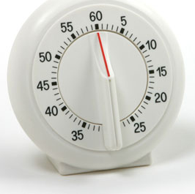
The duration of frying is the 2nd major variable. While you will develop a standard frying duration for your chips and fish it’s not as though you can simply set an alarm clock and wait for the bell to go off.

There is a bit of art involved as well or at least some judgement on the part of the frier who needs to decide whether or not they need an extra 30 seconds in the hot oil, or even if they have to come out a little early.

Too high, too long, too low, too soon?

To help you manage temperature and time we have listed some of the typical symptoms of not quite getting it right.

- Too Low a Frying Temperature
  - Batter may not seal quickly and this can result in batter ‘leaking’ oil into the fish;
  - Batter may not cook all the way through and will be mushy inside, although this is more commonly associated with batter that is too thick;
  - Batter doesn’t cook through and becomes soggy on the underside during storage in the hot cabinet;
  - Chips are undercooked and have too high a water content making them mushy and poor to store in the hot box. They may in the worst cases be uncooked in the centres.

- Too High a Frying Temperature
  - Batter browns quickly on the outside and if frying is stopped too soon the fish may nor be cooked thoroughly inside. Normal duration combined with too high a starting temperature may result in dried out fish;
  - Chips will be browned and dried out;
  - Oil breakdown will be accelerated and deterioration may cause further problems with oil management.

- Frying Duration Too Short
  - All other things being equal, the fish and chips will be undercooked. If only slightly undercooked then it may not be too noticeable by your customers.

- Frying Duration Too Long
  - Fish dries out as too much water is driven out as steam;
  - Chips brown too much and become drier and harder.

Other problems

Here is a list of not uncommon problems and their potential causes and/or solutions.

Cause - Chips with too high a sugar content.

Problem - Brown chips, dark oil. Chips that are cooked correctly but still appear much browner than they should. Caused by caramalisation of excess sugar in the chips. Oil breakdown may also be accelerated.

Solution – Avoid using potatoes with excessive sugar by careful storage, testing of sugar levels and treatment to remove excess starch and sugar (starch doctor, hot water washing) – see Sugar Content towards end of Section One.

Cause - Batter is too thick

Problem - Batter does not fully cook through and the fish may be undercooked even though everything appears (on the surface) to be OK.

Solution – Test your batter to make sure it is a consistent ‘thickness’.

Cause - Batter too thin.

Problem – Batter may ‘blow off’ or explode or crack during frying producing oil soaked soggy batter and dried out fish.

Solution – Make up the batter to be the correct consistency (thin cream), keep it cool in the fridge, only half fill the batter tin and when not in use place it somewhere away from the heat of the range.

Cause - Poor quality fish.

Problem – Customer complaints (rare) lost customers (more likely), poor word of mouth reputation (almost certain).

Solution – Choose a fish quality level appropriate to your business, customers and preferred reputation. Assess the quality of fish you are supplied on a regular basis and if you are less than delighted then take it up with your supplier.

SECTION FIVE

THE STATE OF FISH STOCKS AND THE MARINE ENVIRONMENT

Sustainability and responsibly sourced fish and shellfish lies at the heart of the 21st-century seafood industry.

Sustainable harvesting methods and a commitment to responsible sourcing are now more widely seen in the UK seafood industry as necessary for future food security and as a response to emerging customer requirements.

This part of the workbook is intended to provide you with basic information so that you can respond effectively to customer enquires and concerns over the state of fish stocks, supplies and the marine environment.

Can I defend my sourcing policy?

There are four broad categories that fishing can fall into with regard to the ‘respectability’ of the activity.

At one extreme we have Illegal, Unreported and Unregulated (abbreviated to IUU) fishing which is no better than pirate fishing.

At the other extreme we have fully sustainable fishing that has considered the impacts of all aspects of the harvesting and supply chain. These fisheries are well managed, productive and should remain so in the long term.

In between we have legal fishing that operates within the law but which take into account few if any criteria relating to responsible fishing methods and sustainability. And then we have responsible fishing that takes account of sustainability criteria and endeavour to harvest responsibly.

IUU | Legal Fishing | Responsible Fishing | Sustainable Fishing
Bad | OK | Better | Best

The Seafish Responsible Fishing Scheme audits the practices of vessels, skippers and crew against criteria related to good fishing practice, the equivalent of good manufacturing practices on land.

Sustainable fisheries are assessed and approved by organisations such as the Marine Stewardship Council (MSC) using a Code of Conduct developed by the FAO, a United Nations organisation responsible for food and agriculture (including fishing and aquaculture).

For more information please consult the Seafish Guide to Sustainability available via the Seafish website.

Seafish have produced more than 25 Guides to the responsible sourcing of individual fish and shellfish species. These guides provide a wealth of information about the state of individual fish stocks including key species such as cod, haddock and plaice. They are available free of charge from the Seafish website and the following ‘typical questions’ have been answered using information found in the Guides. These typical questions are our best guess at the kinds of questions the more environmentally-aware customer may ask.

Bottom trawling, it just destroys the seabed doesn’t it?

- Bottom trawling was invented in the Middle Ages.
- No fish species have become extinct as a result of bottom trawling.
- The majority of UK (and European) seabed is resilient to the effect of trawling and our seabed, just like our landscape has adapted to our actions over 100s of years.
- There is no significant ecological benefit to banning trawling on fishing grounds that have been trawled for many years and which still have healthy stocks of fish available for harvesting.
- Distant water, unexploited and isolated fishing grounds may contain pristine and unique ecosystems that do deserve to be studied and protected from the kinds of impacts that trawling could present.
- Our marine ecosystems have remained remarkably productive over the last century or so. According to the UN, world marine fish stocks are fairly stable.

Cod stocks are nearly fished out. Where will our cod come from in the future?

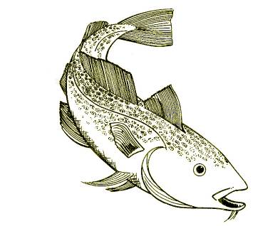
- The world catch of cod is about one million tonnes. In the UK we eat about 25% of this world catch.
- Cod stocks around the UK are at low levels, but management plans are in place and these stocks are recovering.
- There are two species of cod (Atlantic and Pacific) and these are broken up into about 24 different stocks.
- The state of a stock is a balance between reproduction and growth against death from natural causes and fishing. Different stocks are in different states.

- Management plans for almost all of these stocks aim to:
  - Keep healthy stocks at long term sustainable levels;
  - Bring stocks with unhealthy levels of fish back up to a healthy sustainable level.
- Ocean warming affects stocks differently; northern stocks may increase, while southern stocks may decrease:
  - Northern stocks such as those in North Norwegian waters and the Barents Sea are at historic highs and are healthy.
- The UK sources cod globally and we can ensure continued supplies from responsible and sustainable stocks, provided we are willing to pay the price:
  - There are many cod stocks that are MSC certified as sustainable or which are working towards certification.

Haddock are nearly fished out. Where will we get haddock from in the future ?

- The world catch of haddock is around 325,000 tonnes per year and we in the UK consume around 73,000 tonnes.
- Unlike cod, there is only one species of haddock and it is not commercially farmed.
- The general status of haddock stocks in the North East Atlantic is good:
  - The Northeast Arctic and North Sea stocks are at full reproductive capacity;
  - Iceland and Faroe stocks are at risk of being outside safe biological limits and management measures are in place for recovery.
- Haddock stocks naturally have very large variations in stock size.
- Stocks may occasionally be overpopulated and suffer from overcrowding and lack of food.
- Years of poor spawning are often followed by single years with massive recruitment.

For example, the 2003 recruitment for the Georges Bank stock (Western Atlantic) was so high that in 2009 it was agreed the level of haddock stock in that area was double what was needed to be sustainable.

The haddock stocks in the North Sea were high following the exceptionally good recruitment in 1999. As this group of fish disappear quotas need to be adjusted to keep the stock levels healthy.
- The UK sources haddock from all Atlantic stocks and we can ensure continued supplies from responsible and sustainable stocks, provided we are willing to pay the price.

Why doesn’t someone do something to manage fishing?

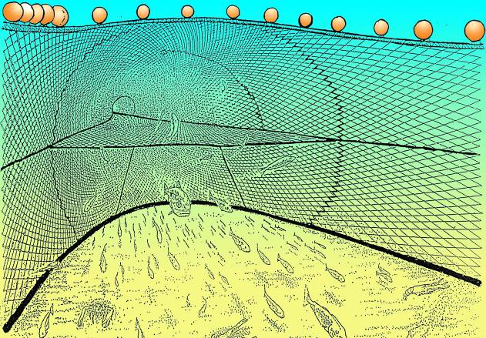
They are, most fish stocks worldwide are being actively managed. Fisheries are very complex. If they were easy to manage it would have been done long ago. There are a number of different tools that governments and agencies use to manage fish stocks. They include:

- Quotas on the amount of fish that can be caught.
- Limits on the types of fishing gears that can be used.
- Restrictions on areas that can be fished, as well as closed and open fishing seasons.
- Incentives for fishermen to fish more responsibly:
  - Using selective fishing gears;
  - Following voluntary fishing bans;

- Supply chain standards that encourage responsible practice by:
  - Fishermen;
  - Merchants and suppliers;
  - Retailers;
  - Food service sector.

What can you (the fish and chip shop owner) do to source responsibly?

- Know your source of supply and stock status – see information available from Seafish and your fish supplier.
- Ensure your supplies are from legal fisheries:
  - Previously there have been serious problems with illegal fishing of certain cod stocks, but tighter controls have eliminated most of these problems.
  - Are your fish supplies traceable and is the paperwork there to prove where they have come from?
  - If in doubt about the status of your supplies, ask your supplier the NFFF or Seafish.

Should I stop buying (or selling) cCod, haddock and other marine species?

- The simple answer is no. Your livelihood and the jobs of thousands of fishermen and fish process workers depend upon a market for their products.
- Although some stocks are considered depleted, many stocks are now considered healthy and are MSC accredited. Management plans are in place to bring as many fish stocks as possible up to full health.

The longer answer is continue to buy and sell cod, haddock etc, but to think about where the fish has come from and how it was harvested. Be prepared to pay a little bit more for your fish if you want higher quality and to ensure that it is sourced from responsible or sustainable sources.

Make sure you capitalise on your additional investment by letting your customers know what you are doing to promote better seafood industry practices through more responsible sourcing.

How can I find out more?

The Sea Fish Industry Authority (Seafish) exists to support the seafood industry with better information and guidance. The Seafish website is a source of much authoritative and useful information, as are Seafish Advisers.

The National Federation of Fish Friers also exists to promote good practices within the fish and chip sector and provides information and training from its offices in Leeds.

SECTION SIX:

ADDITIONAL RESOURCES

Online Resources

Seafood Training Academy – Fish Frying Gallery

- Fish frying skills
  - Part 1 - Buying, preparing, frying and storing fish
  - Part 2 - The batter
  - Part 3 - Potatoes for chipping
  - Part 4 - Frying skills

- Oil Management Guide

Fish Frying

Fish Frying – the movie. A useful training DVD – available from Seafish.

Seafood Quality Assessment Training– a half day training course for fish friers from Seafish.
Torry scheme for cooked cod – see appendix 1

Sustainability

For information on Seafish’s responsible fishing scheme, to download various sustainability and responsible sourcing guides and for guidance please visit www.seafish.org

General

Food Safety training courses from level 1 to level 3:
Available in various languages;
Available as taught courses, open learning programmes and by eLearning;
CIEH and REHIS approved.

Health and Safety training courses:
Level 1 taught course;
Level 2 as a taught course or open learning module.
CIEH and REHIS approved.

For information on all of these training resources and others, contact Seafish:

Seafish Training
Sea Fish Industry Authority
Humber Seafood Institute
Europarc
Grimsby
DN37 9TZ

Tel 01472 252300
Email training@seafish.co.uk

See also: www.seafish.org and www.seafoodacademy.org

For up to date information on resources please visit the Library on the Seafood Training Academy website www.seafoodacademy.org and download the Library Guide for FDQ Learner Workbooks, where you will find links to the above documents and much more.
Appendix 1
Score | Odour | Flavour | Texture, Mouth Feel and Appearance
10 | Initially weak odour of sweet boiled milk, starchy followed by strengthening of these odours | Watery, metallic, starchy. Initially no sweetness but meaty flavours with slight sweetness developing | Dry, crumbly with short tough fibres
9 | Shellfish, seaweed, boiled meat, raw green plant | Sweet, meaty, creamy, green plant, characteristic flavours | Succulent, fibrous. Initially firm going softer with storage. Appearance white and opaque
8 | Loss of odour, neutral odour | Sweet and characteristic flavours but reduced in intensity
7 | Wood shavings, wood sap, vanillin | Neutral
6 | Condensed milk, caramel, toffee-like | Insipid, tasteless as if chewing cotton wool
5 | Milk jug odours, boiled potato, boiled clothes-like | Slight sourness, trace of ‘off’ flavours, possibly slight ammonia | Flesh soft becoming very soft and slimy. Appearance becoming discoloured and yellowish
4 | Lactic acid, sour milk, byre-like | Stronger sourness, slight bitterness, strong ‘off’ flavours, some ammonia
3 | Lower fatty acids(e.g. acetic or butyric acids), composted grass, soapy, turnipy, tallowy | Strong bitterness, rubber, sulphide, definite ammonia

Other assessment schemes exist for other species and for whole fish. See www.seafoodacademy.org for more information.

Assessment Recording Form

To assess the quality of fish samples you should create a full sized form similar to this

Sample number | 1 | 2 | 3 | 4
Estimated age (days) since caught, or Days since delivered/defrosted
Odour description
Flavour description,
Texture Description
Average Torry Score
Good enough to sell in your shop? | Y/N | Y/N | Y/N | Y/N

Arthur Parrington, NFFF Trainer and ex-President
To maximise your return on potatoes, rumble for a little less time, and cut out eyes and marks by hand. It’s time consuming, but gives you the maximum amount of chips to sell from a bag of potatoes.
More than 50% saturated and naturally solid at room temperature. Very little hydrogenated oil is now used in the fish and chip trade.
The other is that hot oil and water can be very dangerous if it causes the oil to boil over.
Too close to the recommended temperature for frying fish and chips for comfort.
A large batch of chilled chips can reduce the oil temperature to this low point around the chips. This may not show up on the range temperature gauge which is sited off to one side where the oil is hottest.
Including vigilance by buyers.
A free to study, level 2 course is available at www.seafoodacademy.org

